THE FRIENDS AND FAMILY TEST

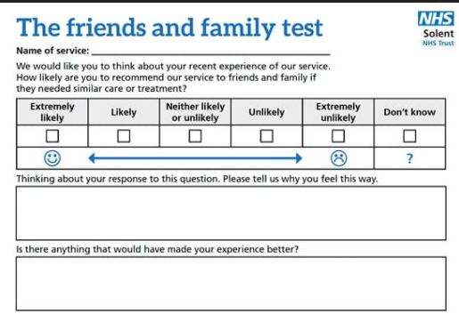

THE FRIENDS AND FAMILY TEST

